# Scratch logo and symbol, meaning, history, PNG

**Scratch Invaders 1**

Register/login at <https://scratch.mit.edu>

*Make the invaders shuffle left and right in a row.*

1. Download **squid**, **crab**, and **octopus** graphics from:  
   <https://codeclub67.github.io/images/invader.gif>
2. Create a new sprite by uploading the *invader* images.

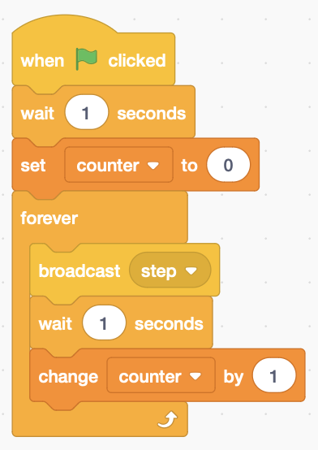*To make all the invaders move together, they need a clock to keep them in time.*

1. Add code to the **stage** that beats out the **steps**, and keeps count (make a **counter** variable, available to all).
2. The squid costume is number 1.   
   Rename the sprite as squid.
3. 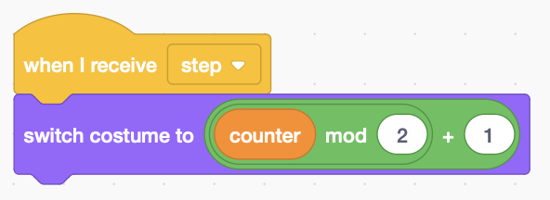Add code to the Invader sprite to **switch costumes** based on the counter. **Counter mod 2** is 0 or 1 for even and odd counts (the remainder after dividing by 2). Add this to the squid costume number 1   
   (3 or 5 for crab and octopus).
4. Add code to make it **move**.

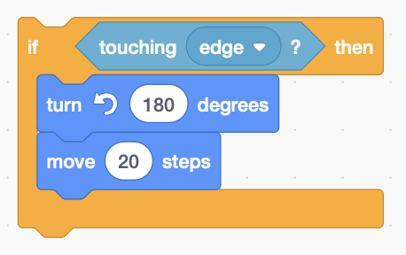*If your invader walks off-screen, get it back by changing x to zero.*

1. 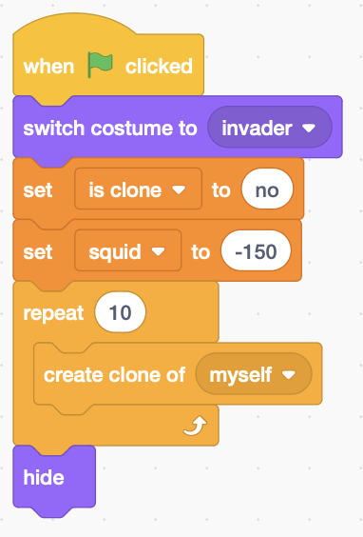Add code to detect the **edge** and **turn** the invader around 180°, and set the invader Direction to *reflect*.

*Instead of making more sprites,****clone*** *the original and then hide it.*

1. Create a **local** variable (this sprite only) to tell if a sprite **is** **clone** (‘yes’ for clones)
2. Create a **global** variable (for all sprites) **squid, crab,** or **octopus** to position them.

*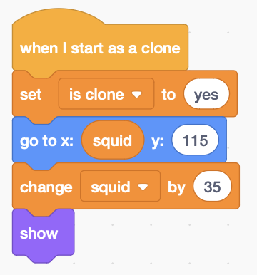Try it! See how they pile up at the edge – now make them all turn at once.*

1. Change the **step** code, as below, to **broadcast** a turn instruction instead.
2. 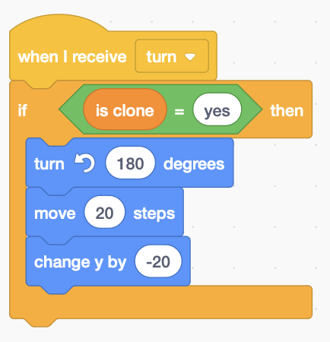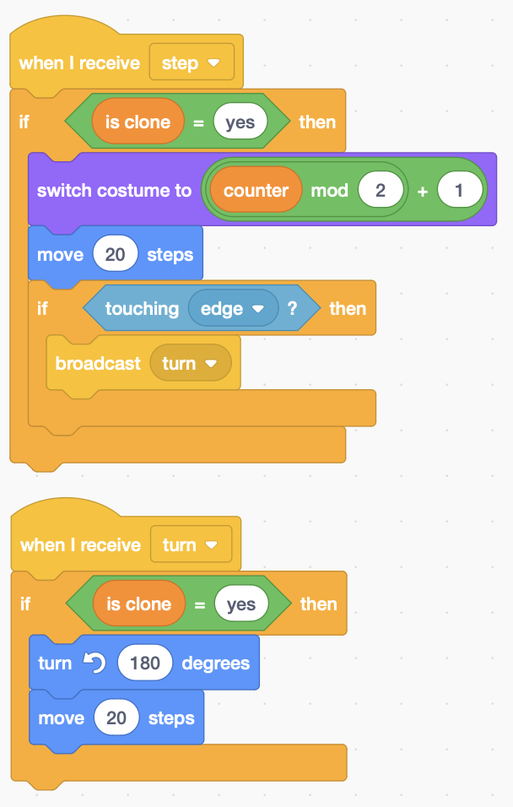Add code to **receive** the turn instruction

*Try adding crab and octopuses on rows lower down.*

***Save*** *your code.*